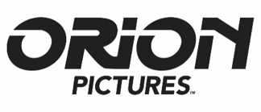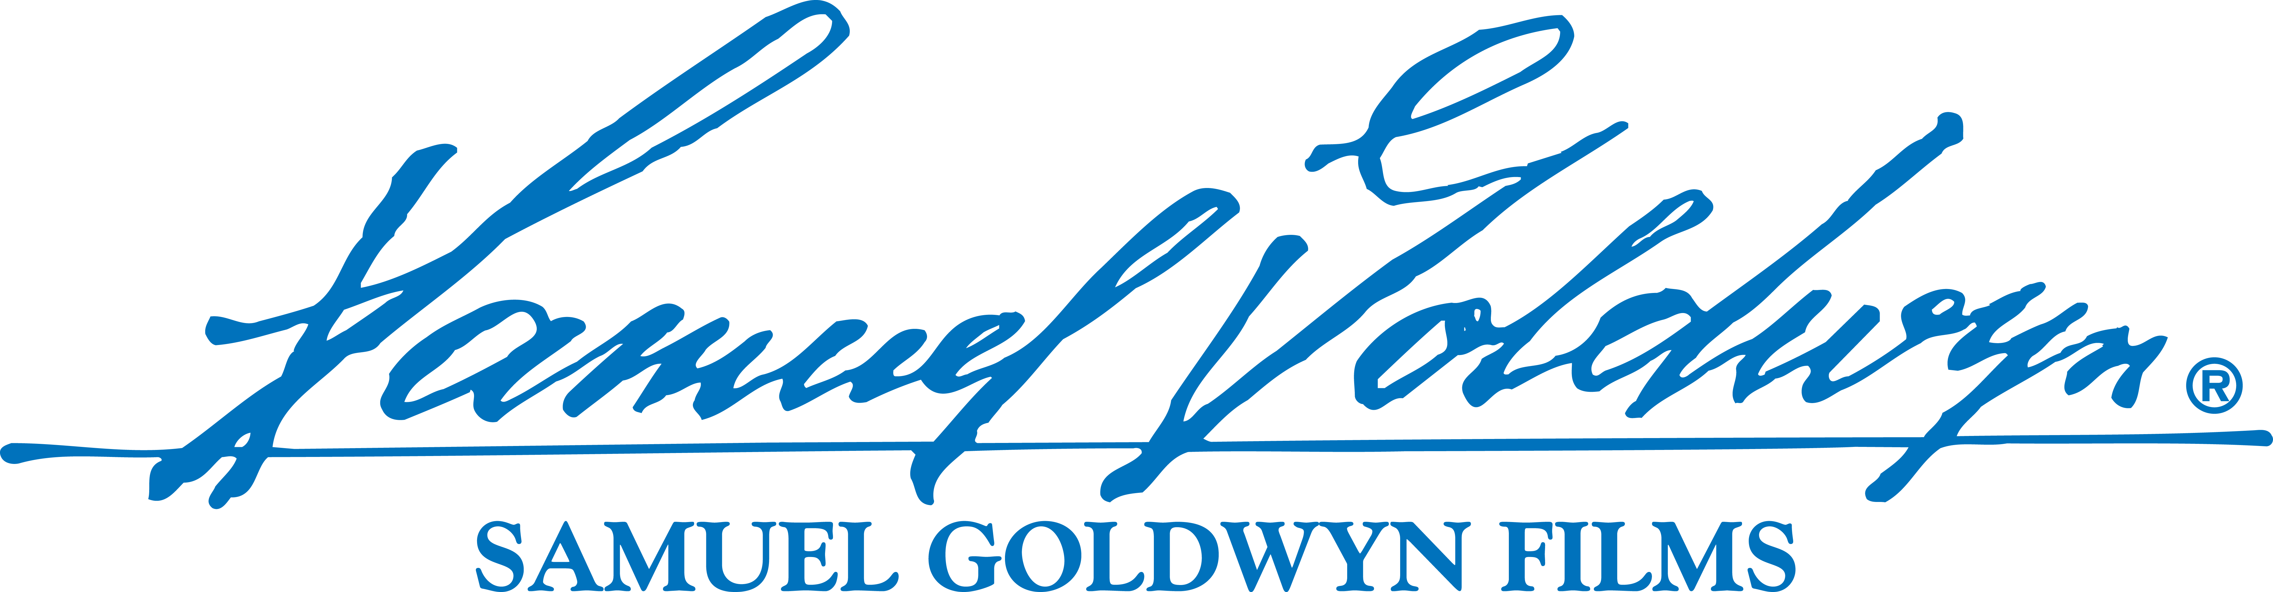
ORION PICTURES AND SAMUEL GOLDWYN FILMS ACQUIRE
AVI NESHER’S ‘PAST LIFE’
Los Angeles – December X, 2016 — Orion Pictures and Samuel Goldwyn Films have secured the U.S. rights to acclaimed filmmaker Avi Nesher’s PAST LIFE from worldwide sales agent Bleiberg Entertainment. The dramatic thriller in its second week of release in Israel is on its way to breaking local box office records.

PAST LIFE was recently announced to screen at the 2017 Palm Springs Film Festival and had its world premiere at the 2016 Toronto International Film Festival.

Inspired by incredible true events, the film is set in 1977 as two Israeli sisters delve into the dark mystery of their father’s story of surviving World War II and discover that it may be more complicated than they originally believed. As cryptic details continue to emerge, the revelations that come to light threaten to tear their family apart.

Nelly Tagar (Zero Motivation), Joy Rieger (Valley), Doron Tavory (Lemon Tree) and Evgenia Dodina (2016 Cannes selection One Week and a Day) head the cast. Nesher (previous TIFF selections The Secrets, The Matchmaker, The Wonders) directs the film from his own screenplay. PAST LIFE is produced by David M. Milch, David Silber, Moshe Edery, Leon Edery, Elad Naggar, Ruth Cats and Nesher.

“We are very excited to be working on Avi’s newest picture. He is arguably one of Israel’s greatest filmmakers. The film is an amazing historical thriller and we cannot wait to bring it to the widest audience possible,” says Peter Goldwyn, President of Samuel Goldwyn Films.

The deal was negotiated by Ehud Bleiberg of Bleiberg Entertainment on behalf of the filmmakers.
# # #

About Orion
Orion, an arm of MGM, is focused on distributing films across multiple platforms.

About Samuel Goldwyn Films
Samuel Goldwyn Films is a major, independently owned and operated motion-picture company that develops, produces and distributes innovative feature films and documentaries.
The company is dedicated to working with both world-renowned and emerging writers/filmmakers and committed to filmed entertainment that offers original voices in uniquely told stories. This is best exemplified by the Academy Award® nominated THE SQUID AND THE WHALE and SUPER SIZE ME, AMAZING GRACE and Julie Delpy’s hit comedy 2 DAYS IN PARIS. Past Goldwyn titles include: HARRY BROWN starring Michael Caine, the box office smash FIREPROOF and the 2010 independent hit MAO'S LAST DANCER. Samuel Goldwyn Films also released THE WHISTLEBLOWER, a powerful, ripped-from-the-headlines thriller starring Academy Award® winner Rachel Weisz, and the 2012 critics’ darling ROBOT & FRANK, starring Academy Award® nominee Frank Langella and Academy Award® winner Susan Sarandon.
Additional Samuel Goldwyn Films releases include: DIANA VREELAND: THE EYE HAS TO TRAVEL; Gilles Bourdos’ RENOIR, the lush film about the famous painter's later years and France's official submission for the 2014 Academy Awards®; Jason Wise’s cult-hit film SOMM; 2015 Academy Foreign Language Film Award® nominee TANGERINES; the Israeli dark comedy THE FAREWELL PARTY; Sacha Jenkins’ FRESH DRESSED; the Sundance cult-hit LILA AND EVE starring Viola Davis and Jennifer Lopez; Damon Gameau’s eye-opening THAT SUGAR FILM which takes on the sugar industry; and Morgan Matthews compelling drama A BRILLIANT YOUNG MIND. Current Samuel Goldwyn Films releases include: Chris Bell’s expose PRESCRIPTION THUGS; Andrew Renzi’s Tribeca Film Festival favorite THE BENEFACTOR starring Richard Gere; the widely anticipated Jason Wise follow-up SOMM: INTO THE BOTTLE; Toronto Film Festival’s Gala Presentation HYENA ROAD directed by Paul Gross; Ted Balaker’s docu CAN WE TAKE A JOKE? in which comedy and outrage collide and TRANSPECOS, the directorial debut and 2016 SXSW Audience Award Winner by Greg Kwedar and Sasha Gordon’s subversive romantic comedy and festival darling IT HAD TO BE YOU. Upcoming films include Ian Old’s award-winning BURN COUNTRY with Oscar winner Melissa Leo, James Franco and breakout lead Dominic Rains; Carles Torrens’ physiological thriller PET starring Dominic Monaghan, Ksenia Solo & Jennette McCurdy and 100 STREETS, an ensemble of interconnecting stories within a vibrant contemporary London starring Idris Elba and Gemma Arterton.

About Bleiberg Entertainment
Bleiberg Entertainment’s slate includes Coming Through the Rye featuring Oscar®-winner Chris Cooper as legendary author J.D. Salinger— currently in U.S. release by Samuel Goldwyn Films; family crime caper Ace the Case with Susan Sarandon; the boxing/mob drama Back in the Day starring William DeMeo and Alec Baldwin; and the international action film Savage Dog, with Scott Adkins, Cung Le and Juju Chan.

PRESS CONTACT:
Samuel Goldwyn Films
Melanie Miller
Melanie@samuelgoldwyn.com
310-860-3150

